1. We will talk about Encryption Algorithm especially; we will talk about **Symmetric Key Encryption Algorithms**.
2. **DES (Data Encryption Standard)**: **Obsolete**
   1. It is Symmetric Key Encryption Algorithm.
   2. So, it uses the same key for encryption and decryption.
   3. Key length **56-Bit**.
   4. Obsolete as it is very easy to decrypt data using this DES algo.
3. **3DES (Data Encryption Standard)**: **Obsolete**
   1. Modification of DES as based on DES algo.
   2. It performs encryption 3 types one after other.
   3. This is also obsolete as vulnerable to different kinds of attacks.  
      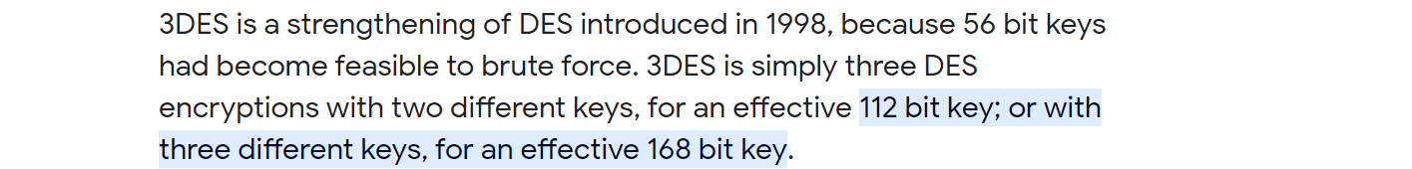
4. **AES**: Modern.
   1. **AES**: **A**dvanced **E**ncryption **S**tandard.
   2. As it is Symmetric Key Algo so uses same key for encryption and decryption.
   3. It allows us to use keys of different lengths.
   4. **For example**:
      1. AES-128 Algo which means it will use 128-bit Key.
      2. AES-256 Algo which means it will use 256-bit Key.
   5. AES is much more secure than DES, 3DES Algos as its key of higher length.
   6. **AES** algo is used in **TLS** (Transport Layer Security) over **HTTPS** Protocol.
5. **NOTE**: There are other obsolete Symmetric Key Algos too.
6. A diagram of a computer algorithm

   Description automatically generated